French 3 –Translate these sentences from chapter 4 Le Nouvel Houdini.

Read through the following sentences created from vocabulary in chapter 4. Translate them into English at the bottom of the page. Answers provided in the folder marked answers on my webpage.

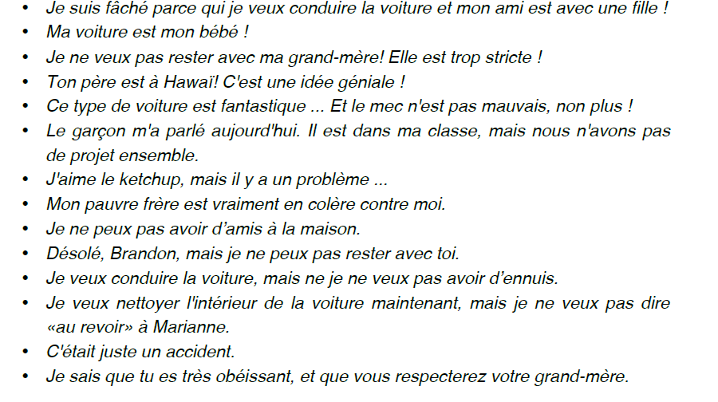

Translate these into English here 1-14.